We’re going to keep returning to the table described in figure 3.6 for the next few chapters and to do test queries for studying. Use this guide to easily create a working version of the data for that table. Entering all of this data manually is a pain, so I took a photo of page 72 in the book and used ABBYY Finereader OCR to convert the text in the photo to a digital form for Excel. I suppose this guide will apply to whatever version of sql server you’re using.
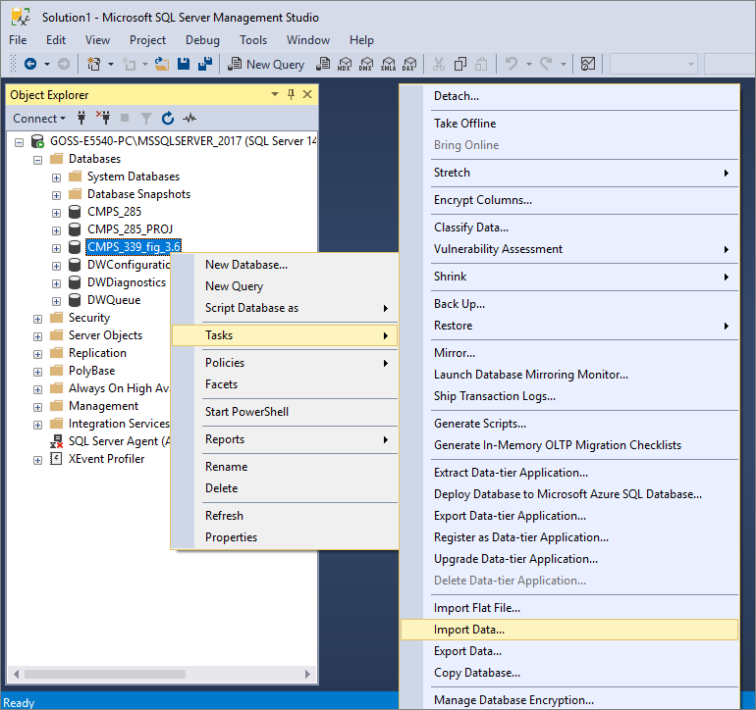
Create a database in sql server. Mine is called …fig_3.6. go to tasks>import data.
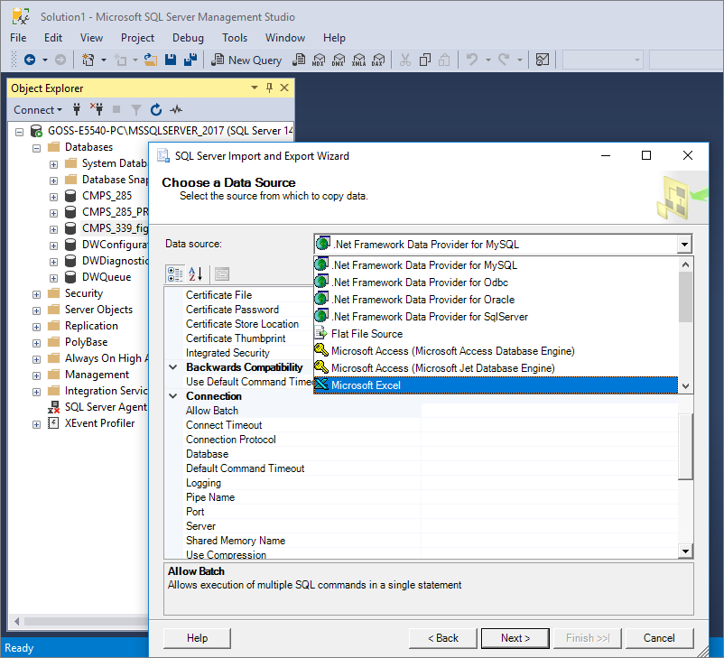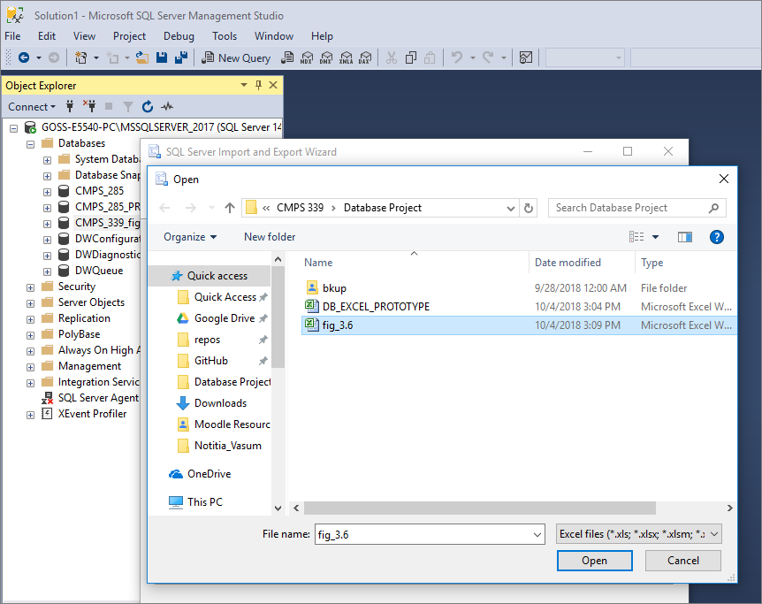
Source will be excel.
Select the excel file.
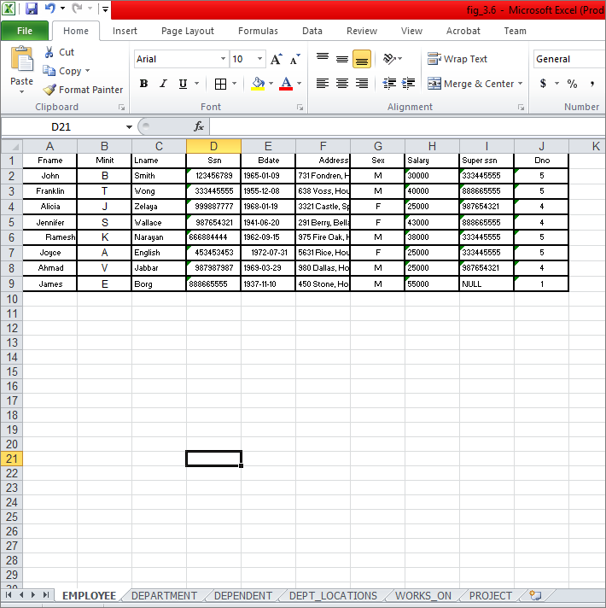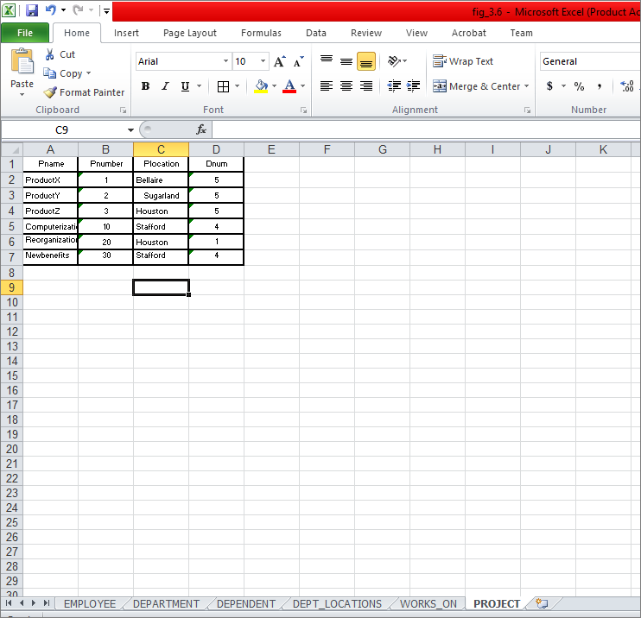
Contents of that excel file.
Contents of that excel file.
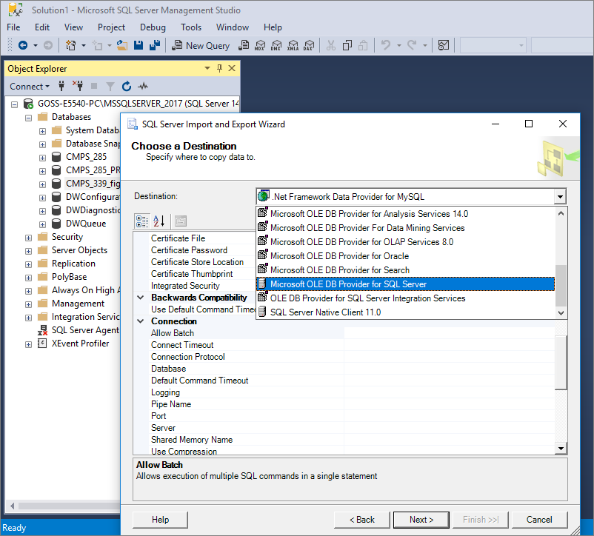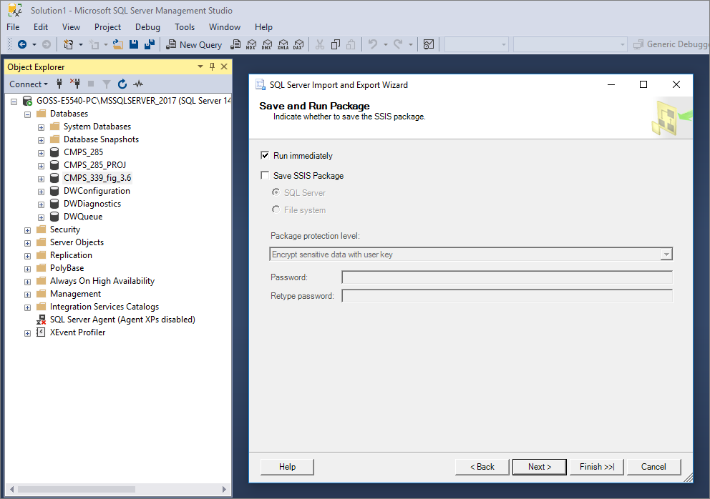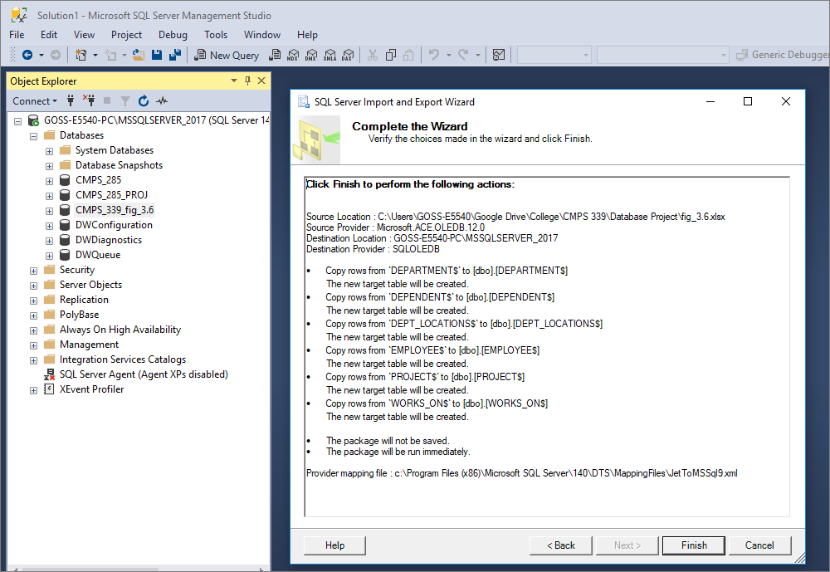
Destination of of the Microsoft ole db provider for sql server.
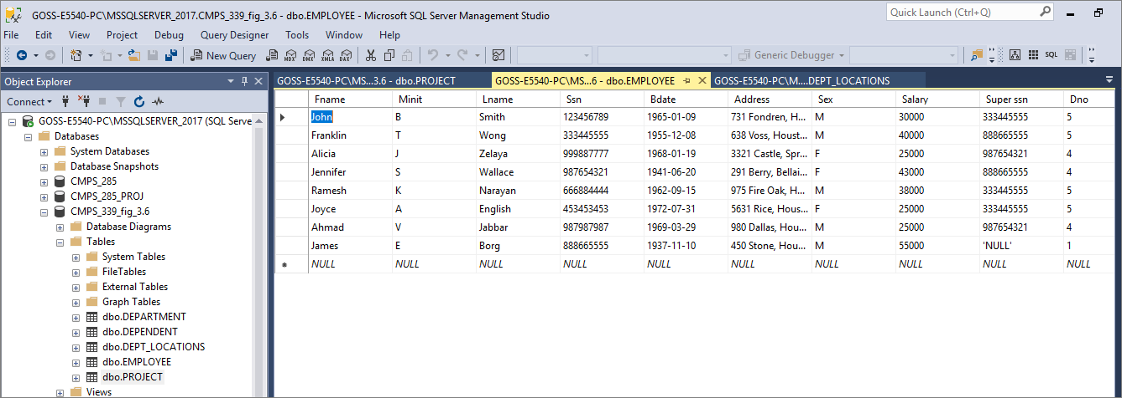
The data is loaded into tables named based upon the workbook names in excel. The attribute names for each table is based upon the entry in the first row of each excel workbook.

